Create a empty XERP db in SQL or SQL Express…
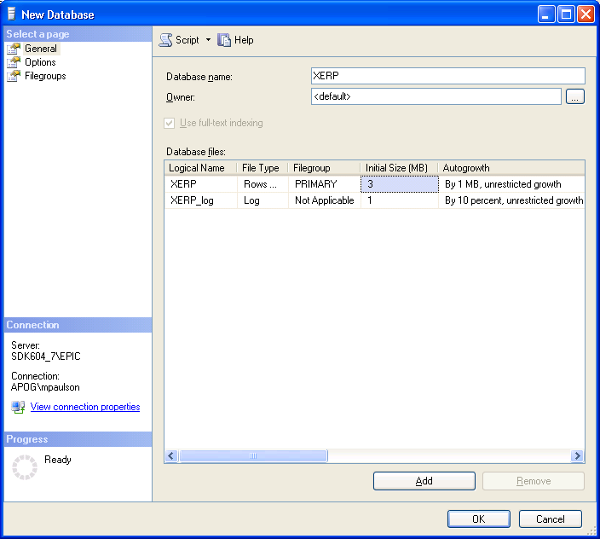

Open up the script and run it… Refresh the tables folder and you will see all the tables we have up to this point…
